PHASE 4
Testing Document

The Fish Inn Statevoice

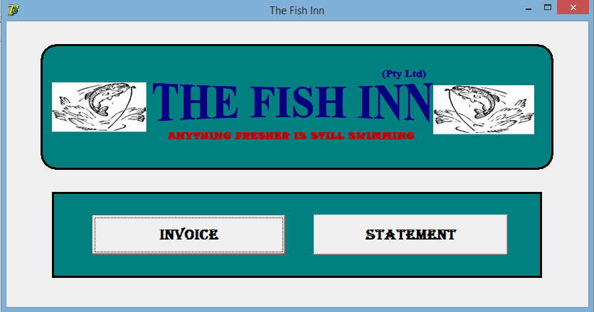

Developed by James Munnik

Signoffs
Phase | Teacher | Date | Signature
4) Testing document | Mrs. Niebuhr

Fulfillment of features:
≪Copy all your features from the Specification document in and tick of whether your program can or cannot do it≫
Feature | Yes | No | Mostly

Specifications of Program Functions

Specifications of User Interface

Specifications of Help

Specifications of Data Storage

Testing data:
≪In this table you must describe all the things you are testing for. Your focus is to ensure that the program fulfils your specifications as set out in the Project Specifications document. Make sure that you plan the testing before you actually do the program! Use a big variety of data to test. ≫
Description of what is tested | Testing data | Results
≪Describe what you tested for≫ | ≪Give a list or explanation of data entered ➔ “good”/correct/valid data AND  “bad” / incorrect / invalid data≫ | ≪Explain what results were obtained≫

